Notes Recognition

1. The REORDER function
   * After reducing the bounding boxes by NMS and grouping them into staffs properly, we will receive a number of lists containing the notes’ positions. The next thing to do is to reorder the notes, corresponding to the actual positions and relations between them on the sheet. This process will make it easier for musicians when they want to work with the sheet through the program.
   * The algorithm is simply based on the stack. Given 2 staffs, one root and one sub.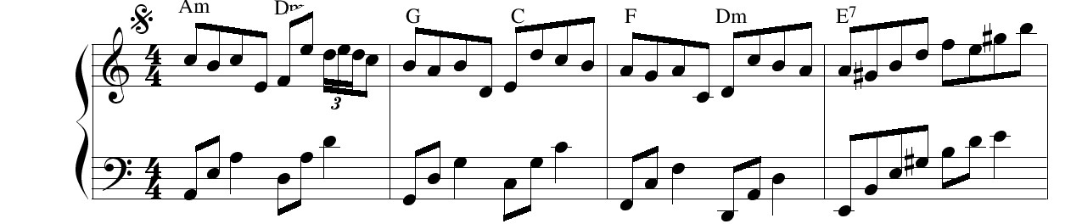

E.g:

As in the example above, the staff with the treble clef is considered as the root staff and the staff with the bass clef below is considered as the sub staff. From the staff, the above image for example, we will have to list carrying the notes, we will call them A and B corresponding to the main and sub staff. Besides, we create 2 empty lists, respectively named A’ and B’.

Now the algorithm will check the first element of A and B simultaneously, which will be called “a” and “b” in short. If they are “horizontally overlapping”, they will be moved from A, B to A’, B’ respectively. For the horizontal overlapping check, we introduced a threshold value which is not larger than the horizontal size of a note, which is used for the overlapping checking process. Please be noted that the “moving” we are using here means that we will add “a” to A’ and remove a from a simultaneously, not just add a copy of “a” to A’. If “a” and “b” are not horizontally overlapping, we will move a or b to A’ or B’ based on their horizontal positions. The one which appears first, or it is lying to the left of the other, will be moved to its corresponding list A’/B’ and the other list will append a (0,0) tuple. If one original list runs out of notes, A for instance, then A’ will append (0,0) and B’ will append b and vice versa. This process will stop until 2 original lists, A and B, run out of notes.

2. Notes Translation.

This one is more simple than the previous one, which is just using the vertical distance between the notes and the first staffline of the staff that the notes belong to.

We have designed 4 lists containing note names, 2 for the root staff and 2 for the bass staff, which is specified for the sheet used in this code. The lists are defined as follow:



Pic 1: notes standing below the 1st staffline, root staff



Pic 2: notes standing above the 1st staffline, root staff



Pic 3: notes standing below the 1 st staffline, sub/bass staff



Pic 4: notes standing above the 1 st staffline, sub/bass staff

To retrieve the names from the lists above, it is based on the index value I, which is defined as follow:

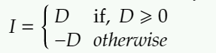

where



h’, h are the vertical position of the note and the 1st staffline respectively

d is the distance between 2 stafflines in a staff.

* The note name we want is A[I], where A is the list containing names of notes
* If D is a non-negative number, the note name is retrieved from the list containing notes standing below the 1st staffline and when D is a negative number, it will be retrieved from the list containing notes standing above the 1st staffline.